OneDrive Storage
Official URL: https://services.smsu.edu/TDClient/180/Portal/KB/Article/3034/OneDrive-Storage
Category: Knowledge Base > Information Technology Services > Software and Applications > OneDrive Storage
Tags: onedrive
_____________________________________________________

Overview
Every student, faculty, and staff have access to Microsoft Office applications such as OneDrive. OneDrive is a cloud-based storage where you can store your documents, pictures, videos, and more. You can access your OneDrive account from your computer by signing into the OneDrive application with your Starid and password. You can also access OneDrive from your web-based email, by clicking on the App Launcher at the upper left corner of your page and selecting OneDrive. With OneDrive, you can synchronize files between your computer and the cloud, so you can get to your files from anywhere - your computer, your mobile device.
Access OneDrive through Microsoft 365: https://www.smsu.edu/email/index.html
Please visit Upload and save files and folders to OneDrive for more information.

Why Use OneDrive?
- You can share and collaborate with others and access these files from any device using Office 365.
- You can share documents by adding collaborators or by sharing a link to the document.
- You can collaboratively work on online documents in Word, PowerPoint, Excel and more.
Learn how to use OneDrive
- Access OneDrive using a web browser:
Login to your SMSU Email: https://www.smsu.edu/email/index.html
Login using your StarID@minstate.edu (Faculty and Staff) or StarID@go.minnstate.edu (Students)
To access OneDrive while logged into your email, click on Apps in the menu located on left side of the page.
On the Apps screen, click the OneDrive icon to access your OneDrive account.
- Login to your SMSU Email: https://www.smsu.edu/email/index.html
- Login using your StarID@minstate.edu (Faculty and Staff) or StarID@go.minnstate.edu (Students)
- To access OneDrive while logged into your email, click on Apps in the menu located on left side of the page.
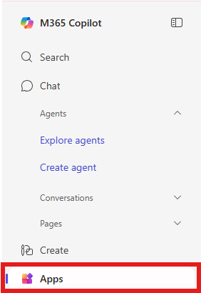
Figure 1: Screenshot
- On the Apps screen, click the OneDrive icon to access your OneDrive account.
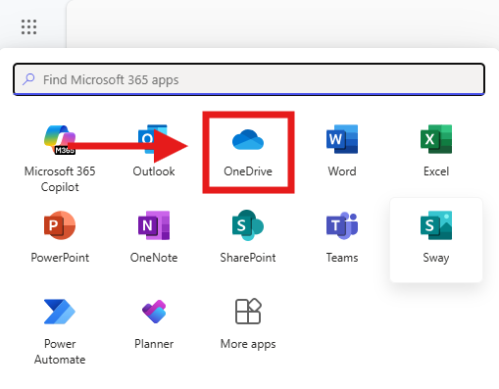
Figure 2: OneDrive Icon
- Upload and save files and folders to OneDrive:
Login to your SMSU email, select the app launcher and then choose OneDrive.
Select + Add new.
Select the files or folder you want to upload.
Select Open or Upload.
- Login to your SMSU email, select the app launcher and then choose OneDrive.
- Select + Add new.
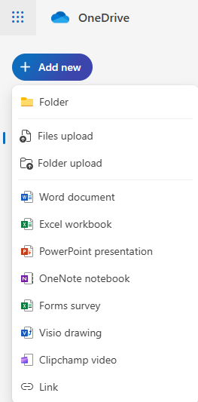
Figure 3: One Drive Add New Document
- Select the files or folder you want to upload.
- Select Open or Upload.
Additionally T-Drive access can be requested. The T-Drive is used for sharing files within your department, or members of a project team. Use this link to request access or contact the TRC Helpdesk if you are experiencing troubles with your network storage.
Accessibility Review & Update Log:
- [x] Content accuracy and link integrity verified
- [x] High-contrast visual hierarchy implemented (Inter and Calibri)
- [x] Image alt-text captions verified (all screenshots captioned)
- [x] PDF attachments scraped and fully inlined directly inside the document
- [x] Outline headers and standard list sequences optimized for screen readers

